SESI 12

1. Visual Studio 2022, Buat Project Baru> Template .NET Core Web API > Nama Project: Unit_TestMock>Setting default>create

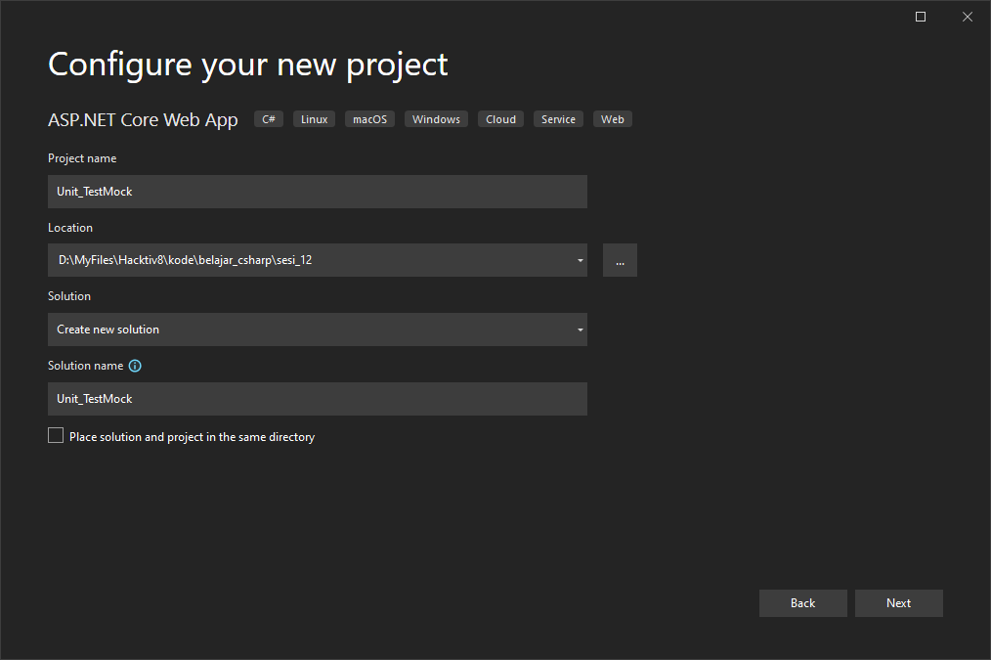

1. Install Package:

* Microsoft.EntityFrameworkCore
* Microsoft.EntityFrameworkCore.Design
* Microsoft.EntityFrameworkCore.Tools
* MySql.Data
* MySql.EntityFrameworkCore

1. Pada ‘Unit_TestMock’ Tambahkan File:

* ‘Models/ApiDbContext.cs’

-------------------------------------------------------------------------------------------------------------------------------

using Microsoft.EntityFrameworkCore;

namespace Unit_TestMock.Models

{

public class ApiDbContext : DbContext

{

public virtual DbSet<EmployeeItem> Employee { get; set; }

public ApiDbContext(DbContextOptions<ApiDbContext> options) : base(options)

{

}

}

}

-------------------------------------------------------------------------------------------------------------------------------

* ‘Models/EmployeeItem.cs’

-------------------------------------------------------------------------------------------------------------------------------

using System.ComponentModel.DataAnnotations;

namespace Unit_TestMock.Models

{

public class EmployeeItem

{

[Key]

public int Id { get; set; }

public string Name { get; set; }

public string Designation { get; set; }

}

}

-------------------------------------------------------------------------------------------------------------------------------

1. Tambahkan kode pada ‘Unit_TestMock/startup.cs’ setelah ‘services.AddSwaggerGen’

------------------------------------------------------------------------------------------------------------------------------- services.AddDbContext<ApiDbContext>(options =>

options.UseMySQL(Configuration.GetConnectionString("DefaultConnection")));

-------------------------------------------------------------------------------------------------------------------------------

1. Migrasi dan Update Database

* dotnet ef migrations add "initial"
* dotnet ef database update

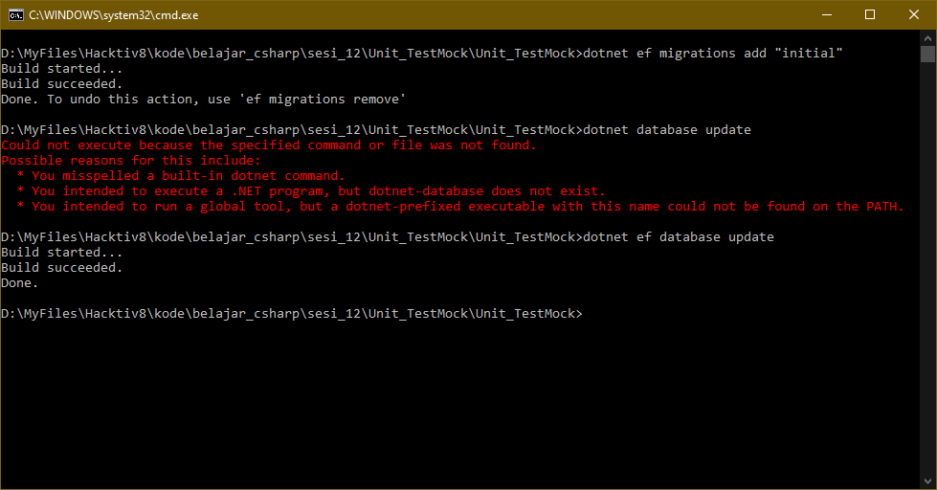

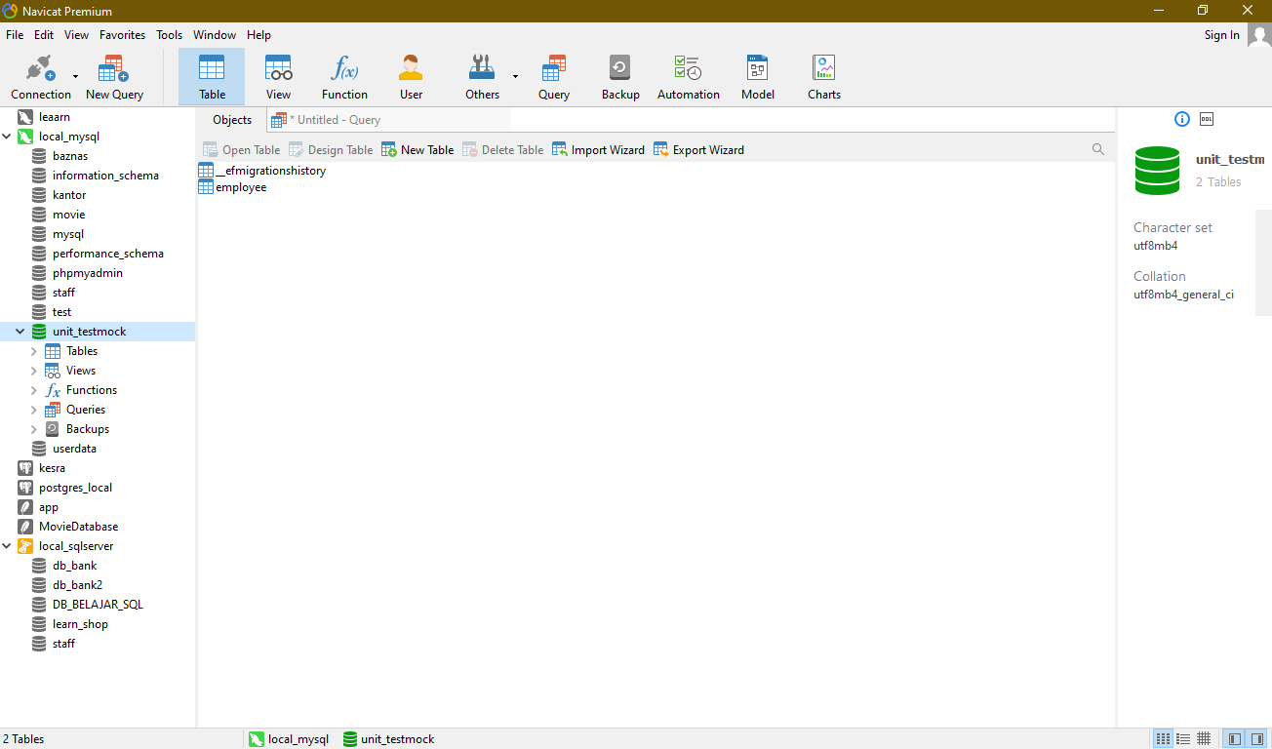

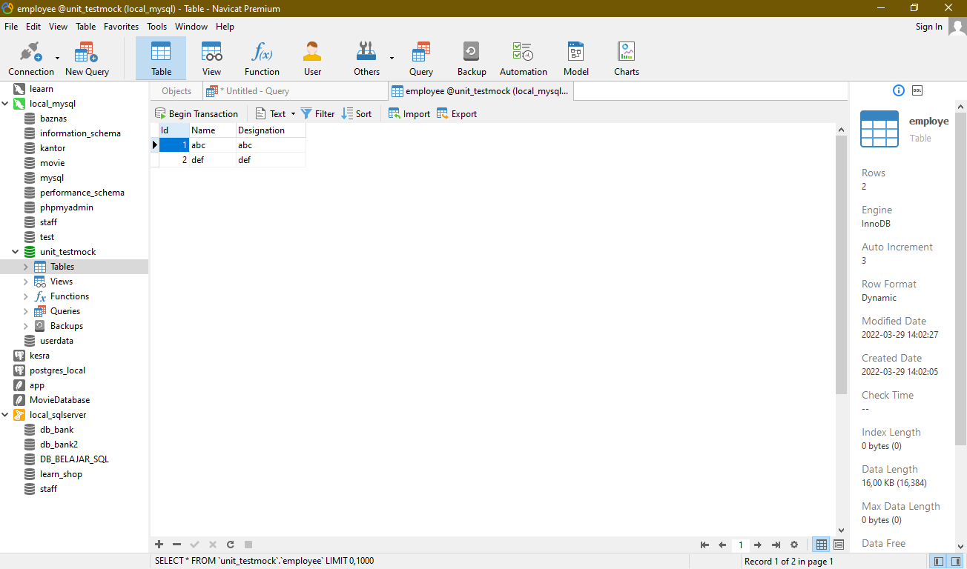

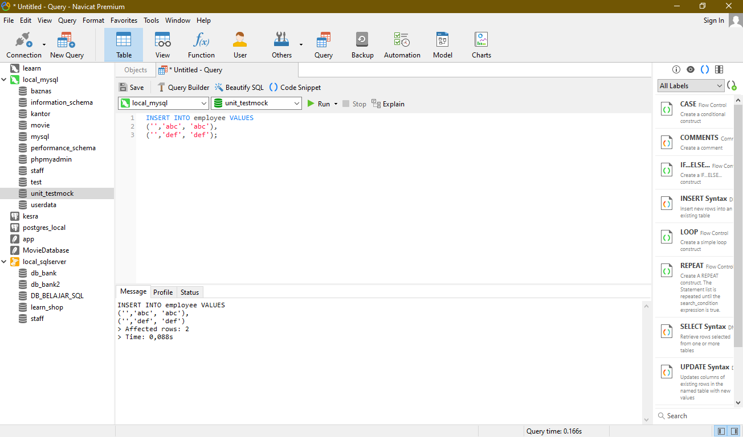

1. Tambahkan File:

* ‘Unit_TestMock/Services/EmployeeService.cs’

-------------------------------------------------------------------------------------------------------------------------------

using Unit_TestMock.Models;

using System.Threading.Tasks;

using Microsoft.EntityFrameworkCore;

using System.Linq;

namespace Unit_TestMock.Sevices

{

public class EmployeeService

{

private readonly ApiDbContext _context;

public EmployeeService(ApiDbContext context)

{

_context = context;

}

public async Task<string> GetEmployeebyId(int id)

{

var name = await _context.Employee.Where(c => c.Id == id).Select(d => d.Name).FirstOrDefaultAsync();

return name;

}

public async Task<EmployeeItem> GetEmployeeDetails(int id)

{

var details = await _context.Employee.FirstOrDefaultAsync(c => c.Id == id);

return details;

}

}

}

-------------------------------------------------------------------------------------------------------------------------------

* ‘Unit_TestMock/Services/IEmployeeService.cs’

-------------------------------------------------------------------------------------------------------------------------------

using System.Threading.Tasks;

using Unit_TestMock.Models;

namespace Unit_TestMock.Sevices

{

public interface IEmployeeService

{

Task<string> GetEmployeebyId(int id);

Task<EmployeeItem> GetEmployeeDetails(int id);

}

}

-------------------------------------------------------------------------------------------------------------------------------

1. Tambahkan kode pada ‘Unit_TestMock/startup.cs’ setelah ‘services.AddDbContext’

-------------------------------------------------------------------------------------------------------------------------------

services.AddScoped<IEmployeeService, EmployeeService>();

-------------------------------------------------------------------------------------------------------------------------------

1. Buat Project baru pada solution yang sama.

Klik Kanan pada solution>Add>New Project

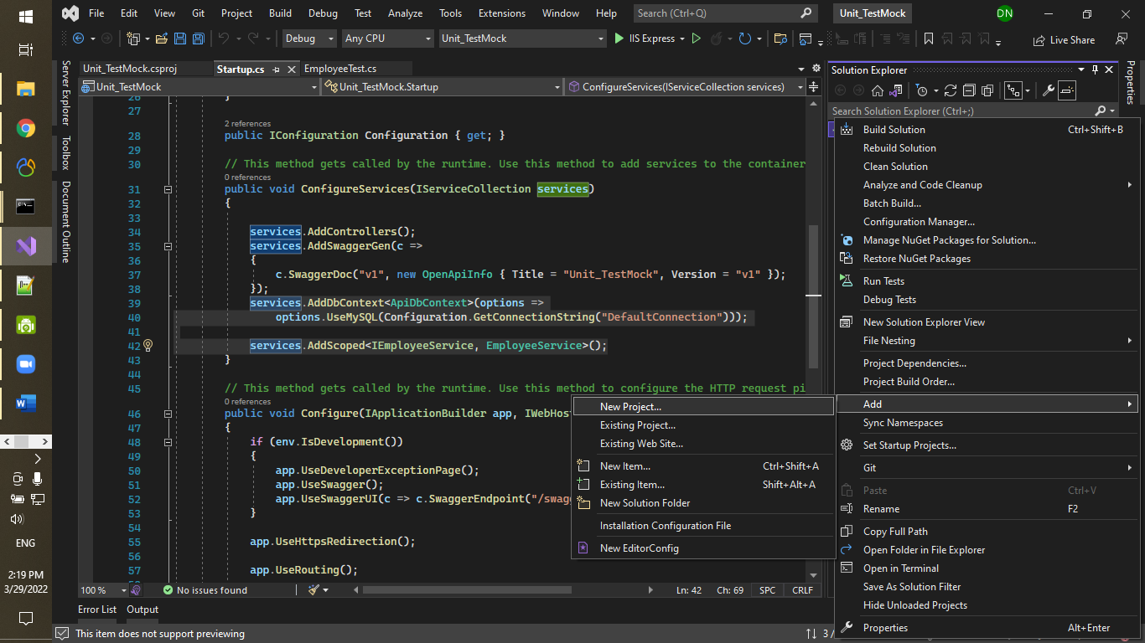

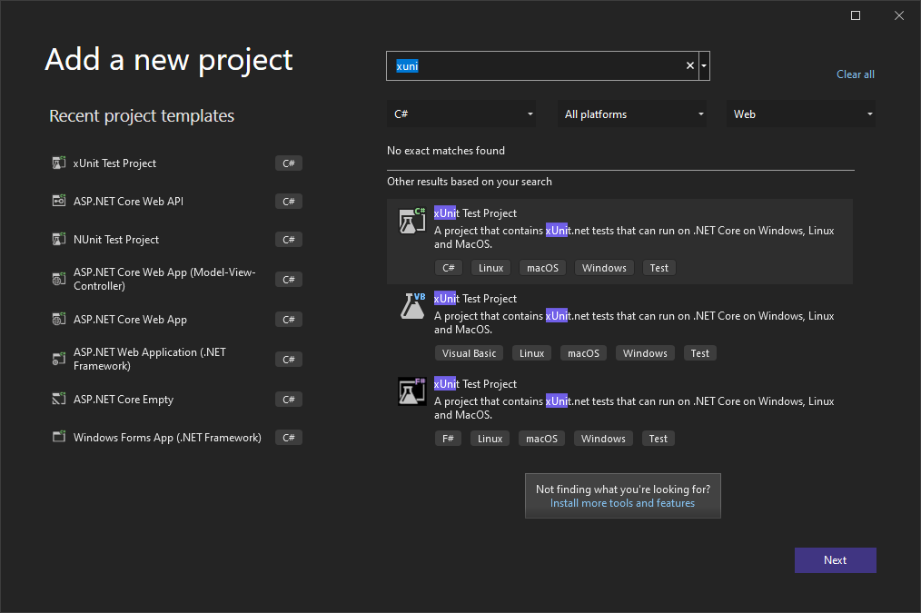

Lokasikan project pada folder yang sama dengan ‘Unit_TestMock’:

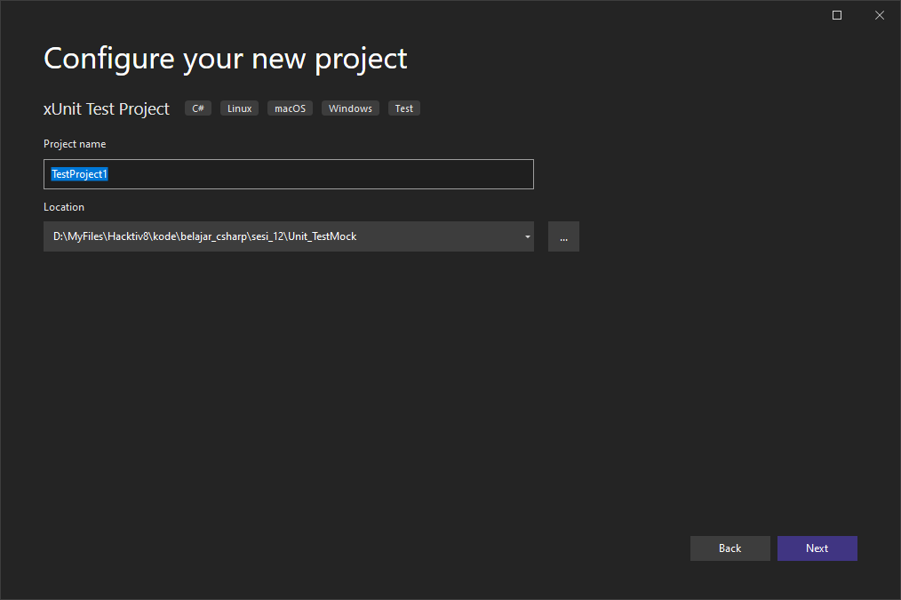

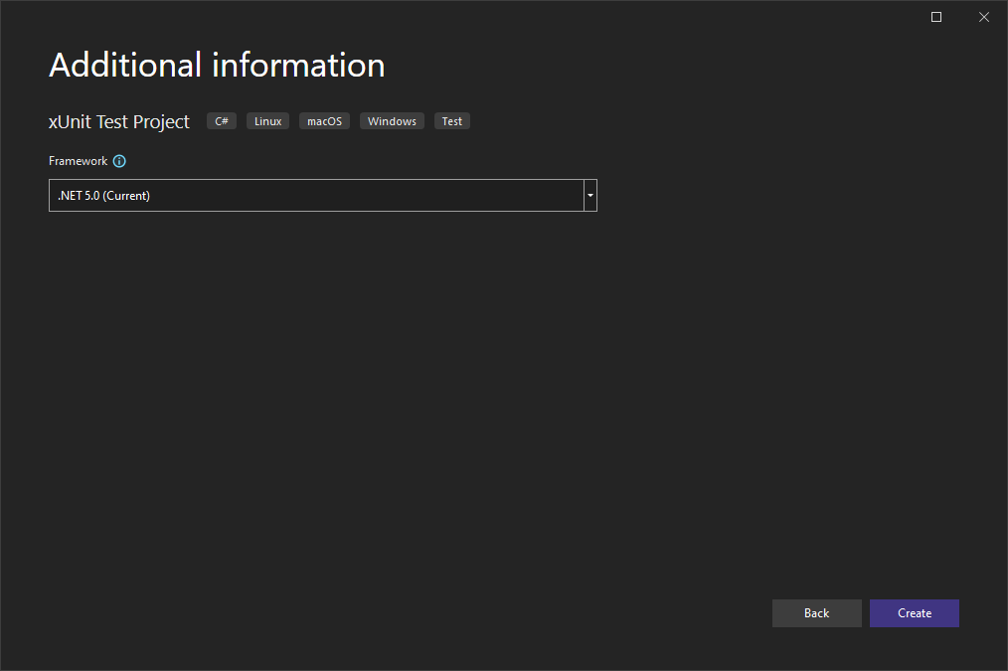

1. Add new class

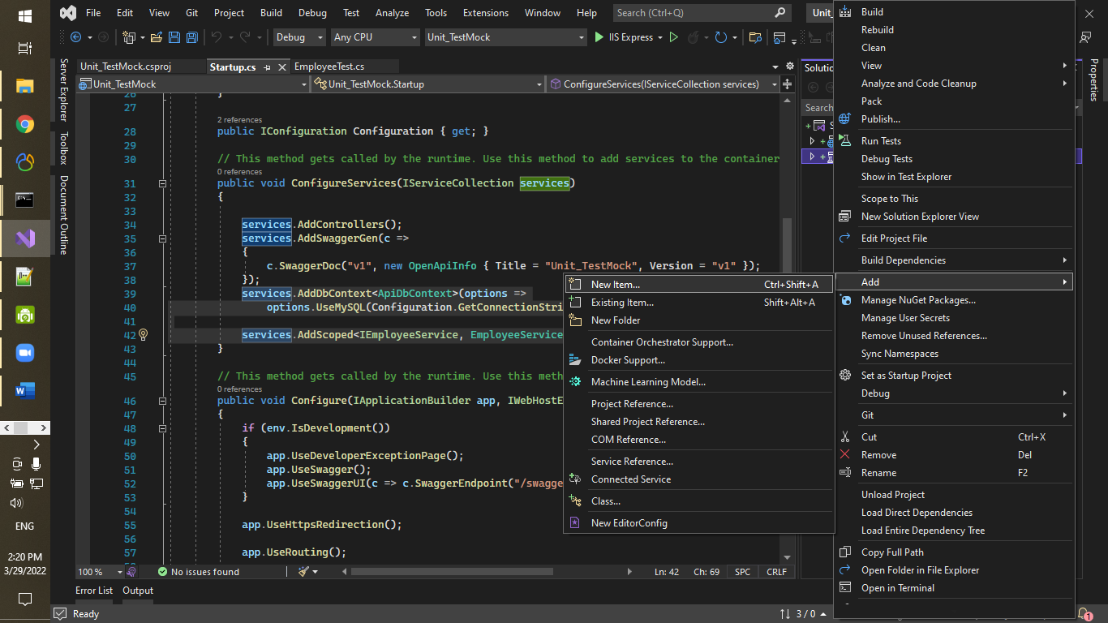

1. Aa

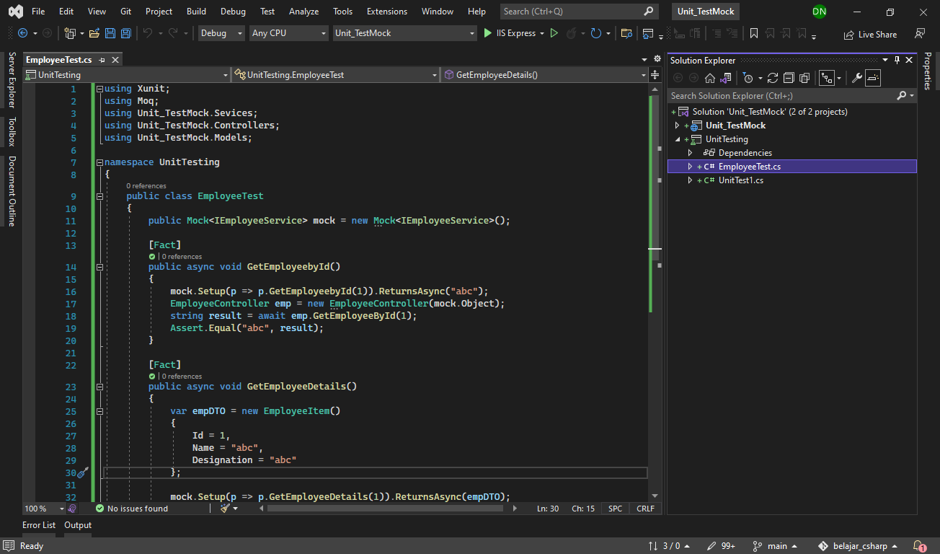

1. A

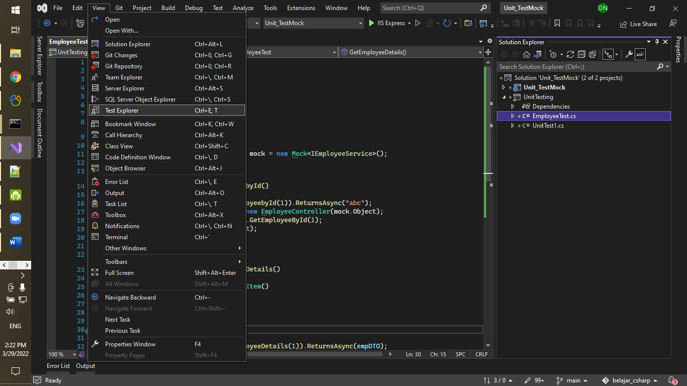

1. Aa

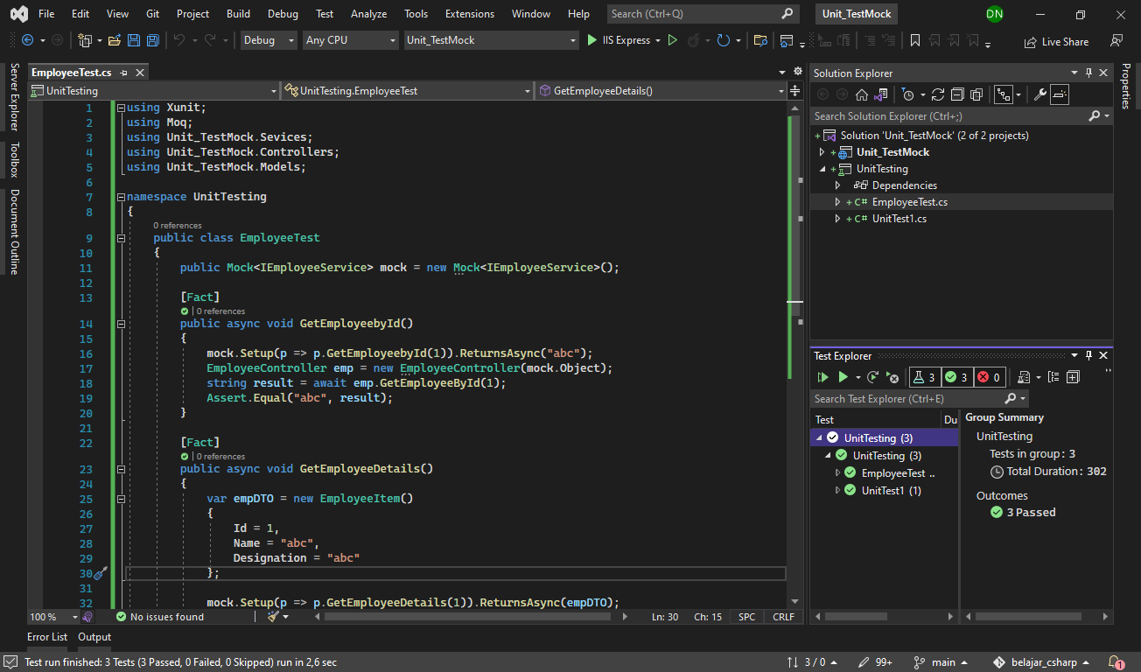

1. A

